Natural Language Processing
3. Syntax Analysis
3.1 Part-Of-Speech Tagging (POS) - Open and Closed Words. Tag Set for English (Penn Treebank), Rule Based POS Tagging, Transformation Based Tagging, Stochastic POS Tagging and Issues –Multiple Tags & Words, Unknown Words.
3.2 Introduction to CFG, Hidden Markov Model (HMM), Maximum Entropy, And Conditional Random Field (CRF).
PAST QUESTIONS:
- What is rule-based and stochastic part of speech taggers? (D23)
- Consider the following corpus
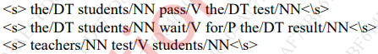
Compute the emission and transition probabilities for a bigram HMM. Also decode the following sentence using Viterbi algorithm “The students wait for the test”. (D23)
- Explain the various challenges in POS tagging. (D23, M24)
- Explain how Conditional Random Field (CRF) is used for sequence labelling. (D23)
- Demonstrate the concept of conditional Random field in NLP. (M24)
- Explain open and closed word classes in English Language. Show how the tags are assigned to the words of following sentence: (D24)
“He used to provide help to other people”
- Discuss the following potential problems in CFG such as 1) Agreement 2) Sub categorization 3) Movement. (D24)
- Explain Hidden Markov Model for POS tagging. (M24, M25)
- Explain types of word classes in English natural language processing. (M25)
- Short note on Rule based taggers. (M25)
NOTES:

*POS :-
Parts of Speech (PoS) tagging is a fundamental task in Natural Language Processing (NLP) where each word in a sentence is assigned a grammatical category such as noun, verb, adjective or adverb based on its context. This is a foundational step in NLP that helps in understanding sentence structure, disambiguating word meanings, and is crucial for many downstream tasks like machine translation and information extraction.
A POS tagger analyzes the word's role within the sentence to assign the correct tag. For example, in "I like the book", "book" is a noun, but in "I book a flight", "book" is a verb.
Part-of-speech the goal of POS tagging is to build a model whose input is a sentence, such as:
Example:
Input: he saw a fox
Output: PRP VBD DT NN
the four words are mapped to pronoun (personal), verb (past tense), determiner and noun (singular), respectively.

*Challenges in POS tagging :-
- Ambiguity: A word's part of speech can change depending on the sentence it's in. For example, "shot" can be a noun or a verb.
- Out-of-Vocabulary (OOV) Words: Taggers struggle with words that were not in their training data, such as new names, technical terms, or misspellings.
- Complex Grammatical Structures: Languages with rich morphology or free word order can be more difficult to tag because the grammatical function isn't always obvious from the word's form.
- Data Limitations:
  - Lack of annotated data: Some languages or specific domains may not have enough high-quality, labeled data to train an accurate tagger.
  - Inconsistent data: Errors or inconsistencies within the training data can negatively affect the tagger's performance.
- Informal and Idiomatic Language: Slang, idioms, and other informal language can be difficult to tag correctly because they may not follow standard grammatical rules.
- Domain Adaption: Models trained on one domain (news) may perform poorly when tagging texts from other domains (tweets, medical notes).

*Open Word Classes :-
Open word classes include nouns, verbs, adjectives, and adverbs, which can constantly gain new words.
These classes easily accept new words.
Vocabulary in these classes is not fixed; new words (neologisms, borrowings, slang) can enter them.
Examples:
  - Nouns (computer, pizza, AI, selfie)
  - Main Verbs (run, eat, google, stream)
  - Adjectives (happy, cool, awesome, digital)
  - Adverbs (quickly, digitally, happily)
Called open because new words are constantly added.

*Closed Word Classes :-
Closed word classes are pronouns, prepositions, conjunctions, and determiners, which have a fixed and finite set of words
These are function words with a fixed set of members.
Rarely accept new words.
Examples:
  - Pronouns (he, she, they)
  - Prepositions (to, in, at, under)
  - Determiners (the, a, this, those)
  - Conjunctions (and, but, because)
  - Auxiliary Verbs / Modals (is, was, have, must, should)
Called closed because the set is limited and stable.
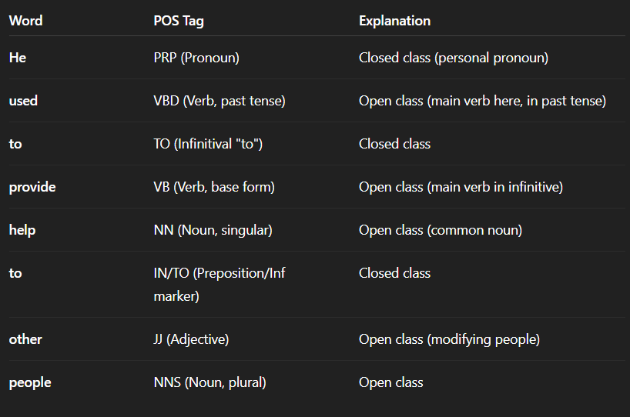

*Rule based POS tagging :-
Rule-based POS tagging assigns POS tags based on predefined grammatical rules. These rules are crafted based on morphological features (like word endings) and syntactic context, making the approach highly interpretable and transparent.
Example:
1. Rule: Assign the POS tag "Noun" to words ending in "-tion" or "-ment".
2.Sentence: "The presentation highlighted the key achievements of the project's development."
3. Tagged Output:
- "presentation" → Noun (N)
- "highlighted" → Verb (V)
- "development" → Noun (N)

*Transformation based tagging :-
TBT refines POS tags through a series of context-based transformations. Unlike statistical taggers that rely on probabilities or rule-based taggers, it starts with initial tags and improves them iteratively by applying transformation rules.
Hybrid of rule-based + machine learning
- Text: "The cat chased the mouse."
- Initial Tags: "The" – DET, "cat" – NOUN, "chased" – VERB, "the" – DET, "mouse" – NOUN
- Rule Applied: Change “chased” from Verb to Noun because it follows “the”.
- Updated Tags: "chased" becomes Noun.
*Stochastic POS tagging :-
Stochastic Part-of-Speech (POS) tagging uses probabilistic and statistical methods from a training corpus to assign a POS tag to each word in a sentence. This approach involves techniques like using the most frequent tag for a word (word frequency) or calculating the probability of a sequence of tags (n-gram approach), with common models being Hidden Markov Models (HMMs). It's a widely used method because it can achieve high accuracy by learning patterns from large amounts of pre-tagged text
These models calculate the likelihood of a tag based on a word and its context, helping to resolve ambiguities and handle complex grammar. Common models include: Hidden Markov Models (HMMs)

*CFG :-
A context-free grammar (CFG) is a formal system used to describe a class of languages known as context-free languages (CFLs).
It consists of a finite set of variables (nonterminals), a finite set of terminals, a start symbol, and production rules that specify how to replace a nonterminal with a string of terminals and/or nonterminals.

*HMM :-
When working with sequences of data, we often face situations where we can't directly see the important factors that influence the datasets. Hidden Markov Models (HMM) help solve this problem by predicting these hidden factors based on the observable data.
HMM is a statistical model that is used to describe the probabilistic relationship between a sequence of observations and a sequence of hidden states.
Hidden Markov Model (HMM) captures lexical and contextual information for POS tagging. They are used to represent and model the relationships between words (observations) and their corresponding POS tags (states).
Here are the fundamental components and concepts associated with Hidden Markov Models:
- States: An HMM models a system as a sequence of hidden states. These states represent underlying, unobservable conditions or situations. For instance, in speech recognition, the states might represent phonemes or words.
The internal unobservable states
Example: states = {Noun, Verb, Adjective}
- Observations: At each time step, the HMM emits an observation based on the current hidden state. These observations are what we can measure or see. In speech recognition, observations can be acoustic features like spectral information.
The visible outputs
Example: words in a sentence
- State Transition Probabilities: HMMs incorporate transition probabilities, which specify the likelihood of moving from one hidden state to another at each time step. These probabilities are typically organized as a transition matrix.
Probability of going from one hidden state to another
Example: P(Verb → Noun)
- Emission Probabilities: For each hidden state, there are associated emission probabilities. These probabilities determine the likelihood of emitting a particular observation when the system is in that state. Emission probabilities are typically represented as emission matrices or vectors.
Probability of a state generating a specific observation
Example: P(“cat” | Noun)
- Initial State Probabilities: HMMs also have initial state probabilities, which specify the likelihood of starting in each hidden state at the beginning of the sequence.
Probability of starting in a particular state
A Hidden Markov Model is a statistical model where the system has hidden states and observable outputs. It uses transition probabilities between hidden states and emission probabilities to predict the most likely sequence of states. It is widely used in POS tagging, speech recognition, and NER.

*CRF :-
A Conditional Random Field (CRF) is a probabilistic graphical model used for sequence labeling in Natural Language Processing (NLP). It predicts a sequence of labels for a given sequence of words by considering context, dependencies, and correlation between neighboring labels.
CRF is discriminative, meaning it directly models P(Y | X), where:
- X = input sequence (words)
- Y = output sequence (tags/labels)
It is widely used in tasks like POS tagging, Named Entity Recognition (NER), chunking, etc.
CRFs are well-suited for tasks where the label of a word depends on the labels of nearby words. For example, in a linear-chain CRF, the tag for a word is dependent on the tag of the previous words.
Unlike models that predict each word in isolation, CRFs model the entire output sequence, which helps prevent errors like incorrectly labeling "apple" as an organization at the beginning of a sentence.
CRFs are discriminative models, meaning they directly model the conditional probability of the output sequence P(Y|X), which is more efficient for prediction.
Applications –
- Part-of-Speech (POS) tagging: Assigning the correct grammatical tag (noun, verb, etc.) to each word in a sentence.
- Named Entity Recognition (NER): Identifying and classifying named entities in text, such as people, organizations, and locations.
- Text segmentation: Breaking down text into meaningful segments.

